|  |  |
| --- | --- |
|  | Report |
|  |  |
|  | Sumaiya Saeha  Student ID: 1905033 |

# How to run the code:

1. My .ipynb file doesn’t require any input. Running all the cells consecutively will suffice. It will automatically generate graphs for four different learning rates and for three different models.

# Hyperparameters:

1. Learning rates = {0.005, 0.001, 0.0005, 0.0001}
2. Batch size = 128
3. Epochs = 10

# Model 1:

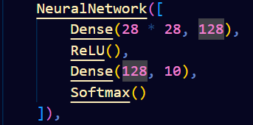

**Learning rate: 0.005**

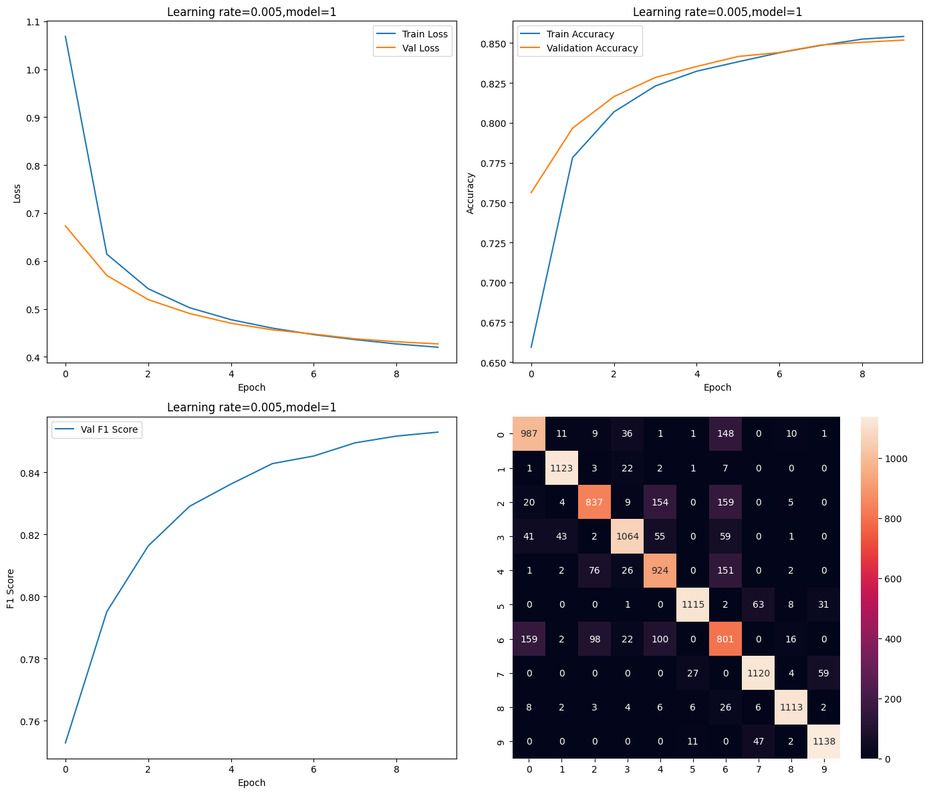

Train Loss: 0.4200356849457073

Val Loss: 0.42699774912634963

Train Accuracy: 85.41250000000001 Val Accuracy: 85.18333333333334 F1 Score: 0.8529322781771764

**Learning rate: 0.001**

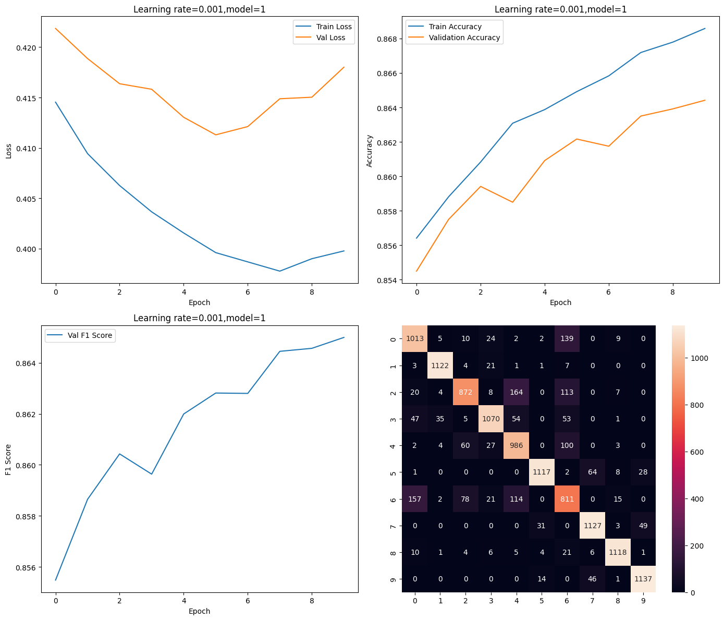

Train Loss: 0.39977970673613616

Val Loss: 0.41800860987868466

Train Accuracy: 86.85833333333333 Val Accuracy: 86.44166666666668 F1 Score: 0.8649896617345065

**Learning rate: 0.0005**

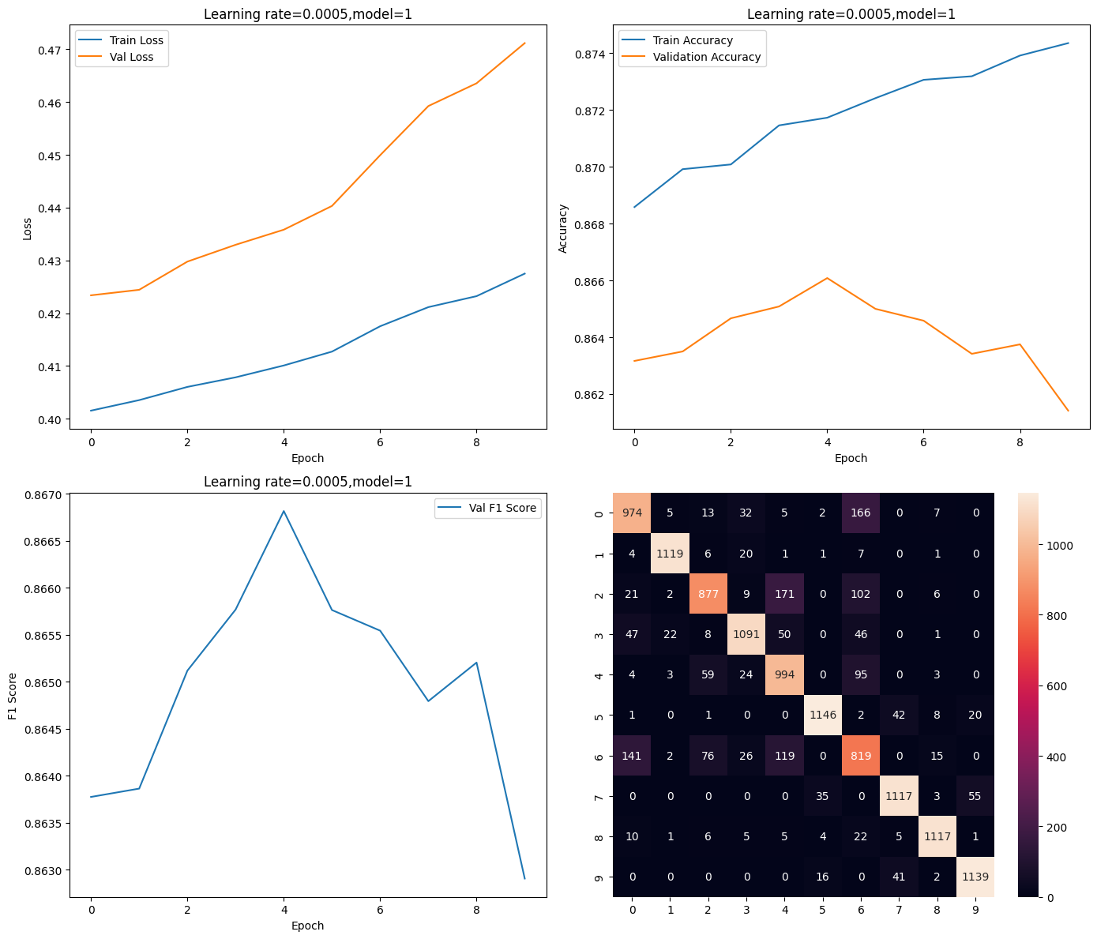

Train Loss: 0.4101036441868

Val Loss: 0.4358172550717032

Train Accuracy: 87.17291666666667 Val Accuracy: 86.60833333333333 F1 Score: 0.8668170636440278

**Learning rate: 0.0001**

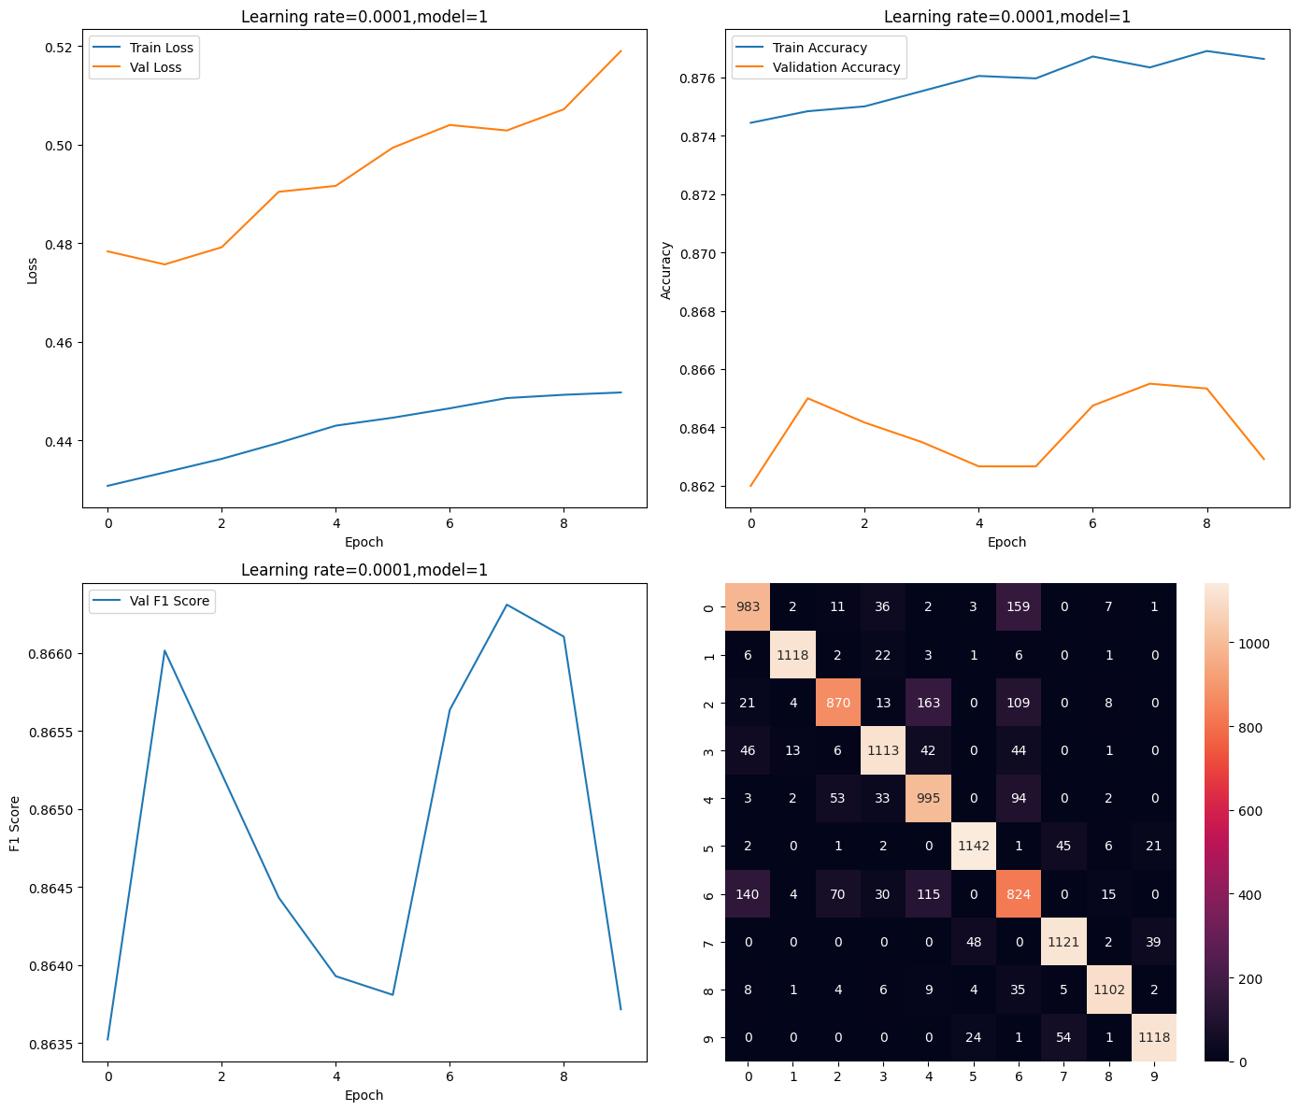

Train Loss: 0.448598793876475

Val Loss: 0.5029043408463831

Train Accuracy: 87.63333333333333 Val Accuracy: 86.55000000000001 F1 Score: 0.8663078875594838

# Model 2:

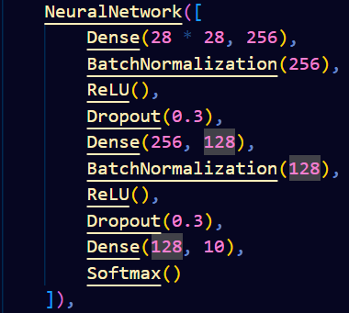

**Learning rate: 0.005**

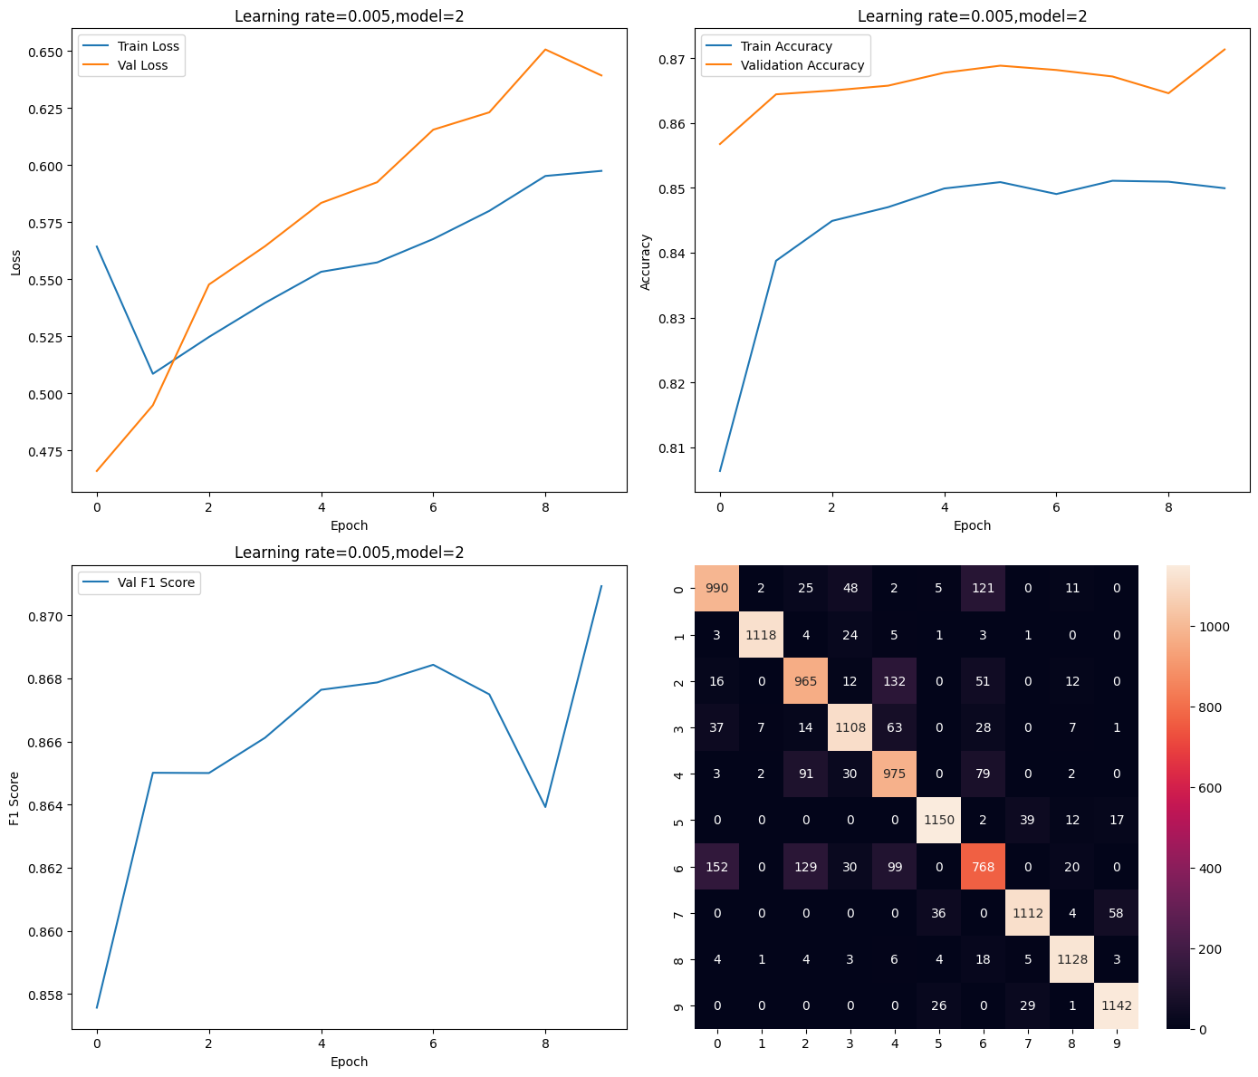

Train Loss: 0.5974058537226535

Val Loss: 0.6391871235879265

Train Accuracy: 84.99375

Val Accuracy: 87.13333333333333 F1 Score: 0.8709245882580952

**Learning rate: 0.001**

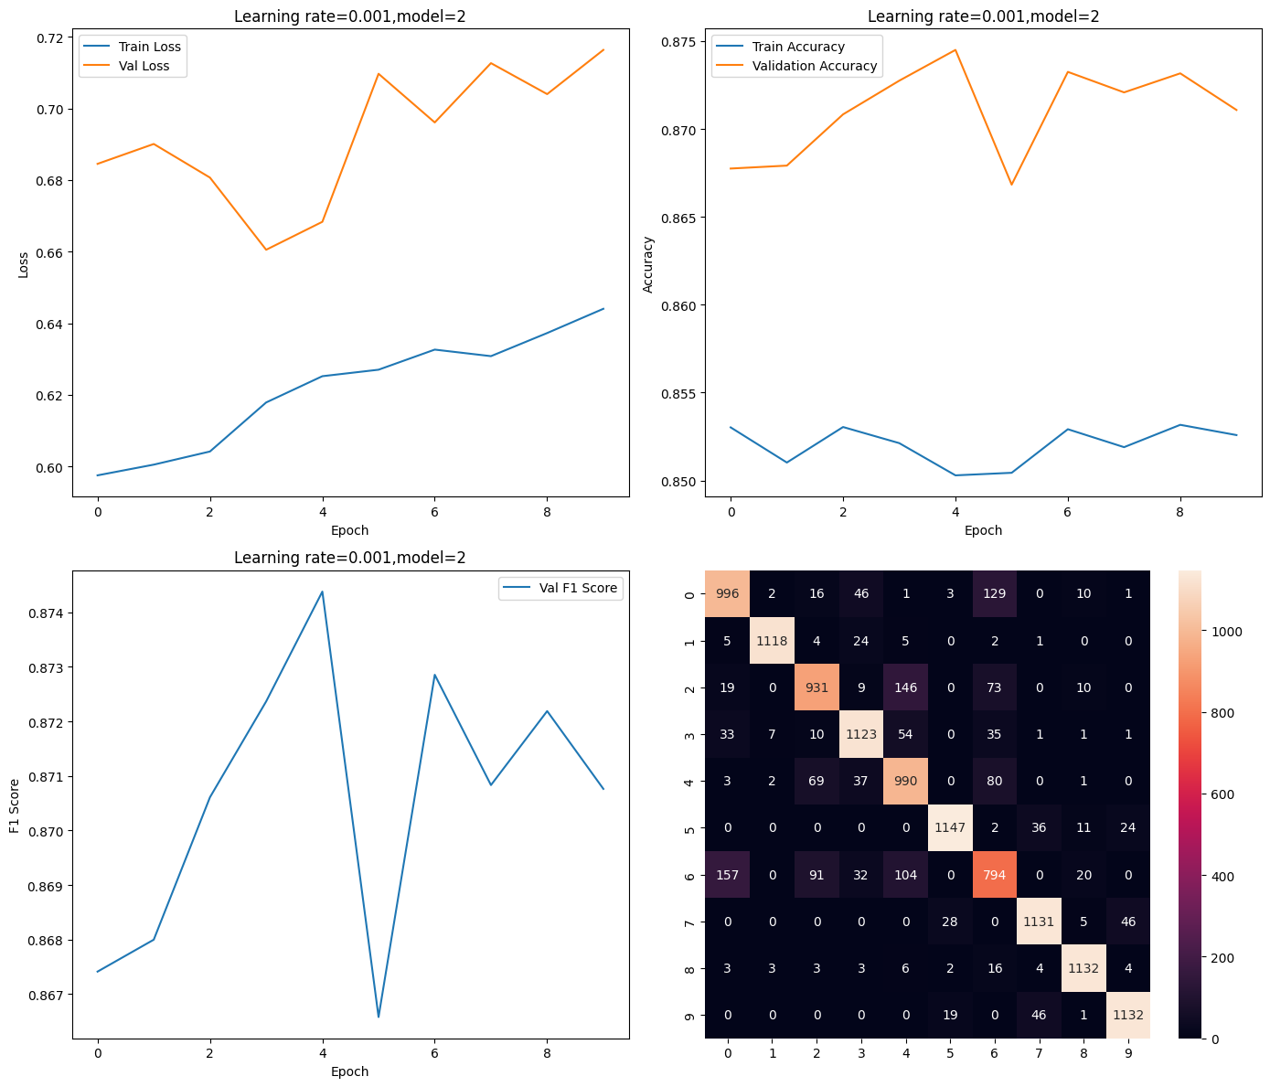

Train Loss: 0.6251971700085104

Val Loss: 0.6683258556647369

Train Accuracy: 85.02916666666667 Val Accuracy: 87.45 F1 Score: 0.8743793769016671

**Learning rate: 0.0005**

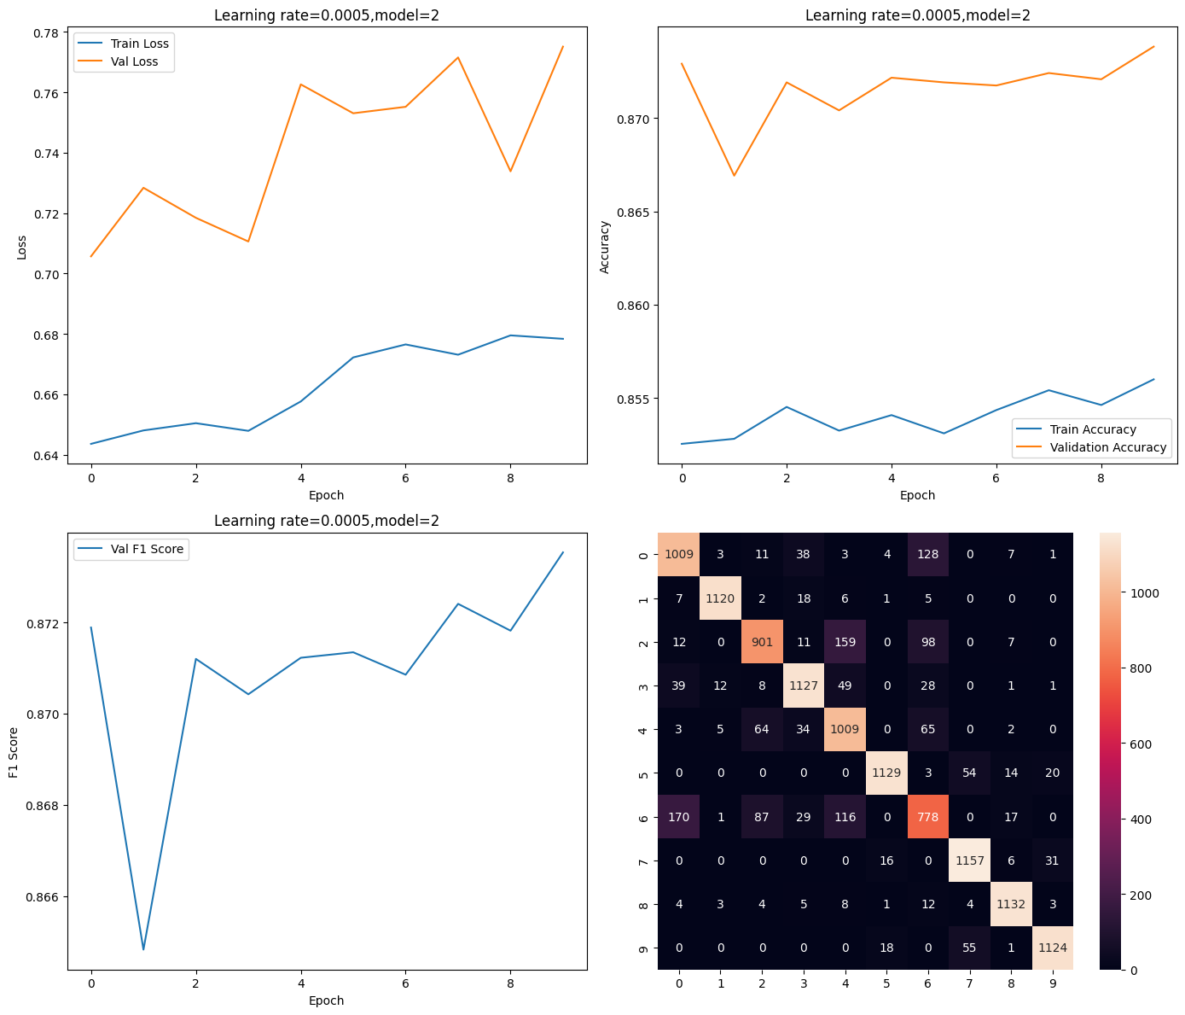

Train Loss: 0.6783796880715985

Val Loss: 0.7751190017513399

Train Accuracy: 85.6 Val Accuracy: 87.38333333333334 F1 Score: 0.8735345353426649

**Learning rate: 0.0001**

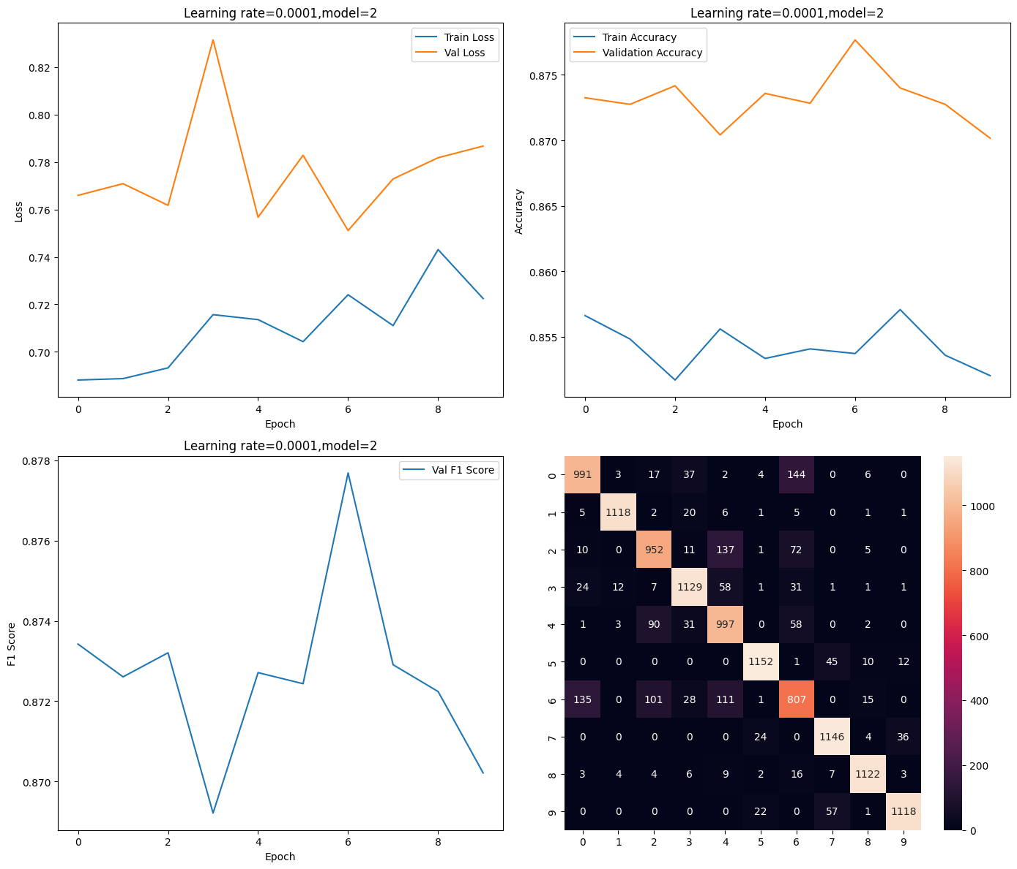

Train Loss: 0.7240686597177313

Val Loss: 0.7511139878881271

Train Accuracy: 85.37291666666667 Val Accuracy: 87.76666666666667 F1 Score: 0.8776860464995957

# Model 3:

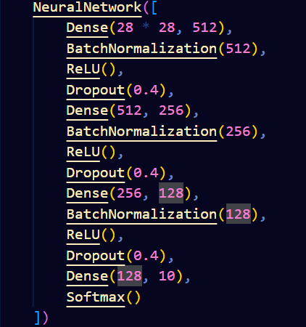

**Learning rate: 0.005**

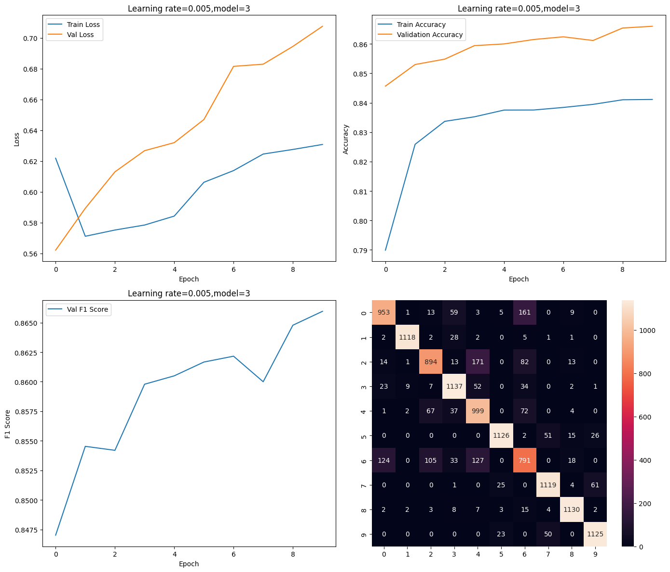

Train Loss: 0.6307396615888059

Val Loss: 0.7074854801757917

Train Accuracy: 84.1125 Val Accuracy: 86.6 F1 Score: 0.8659571844311074

**Learning rate: 0.001**

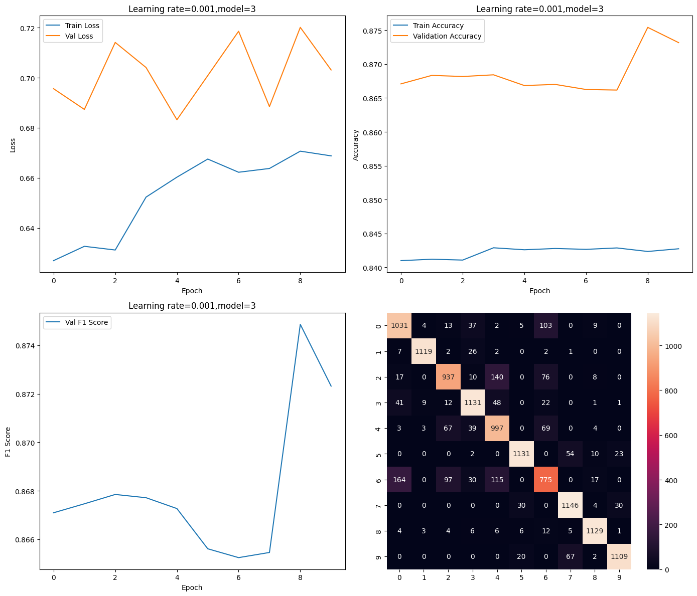

Train Loss: 0.6706593287251433

Val Loss: 0.7201128440268916

Train Accuracy: 84.23541666666667 Val Accuracy: 87.54166666666666 F1 Score: 0.8748620471263729

**Learning rate: 0.0005**

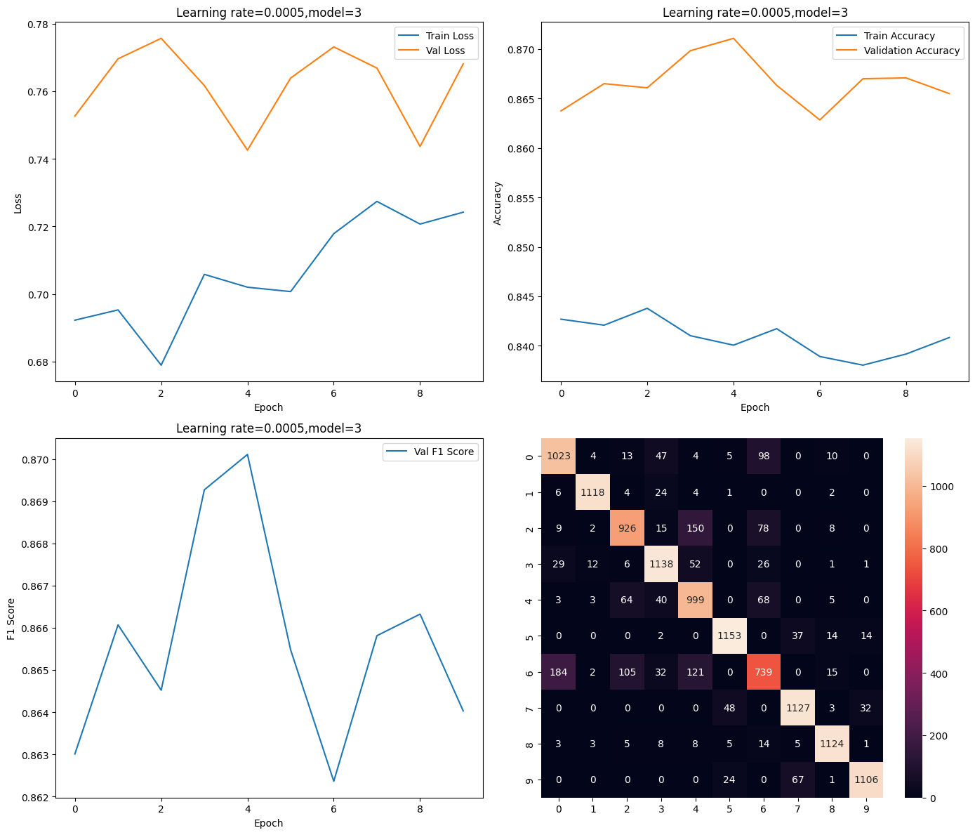

Train Loss: 0.7020128974786782

Val Loss: 0.7425629306132248

Train Accuracy: 84.00625000000001 Val Accuracy: 87.10833333333333 F1 Score: 0.870109529200177

**Learning rate: 0.0001**

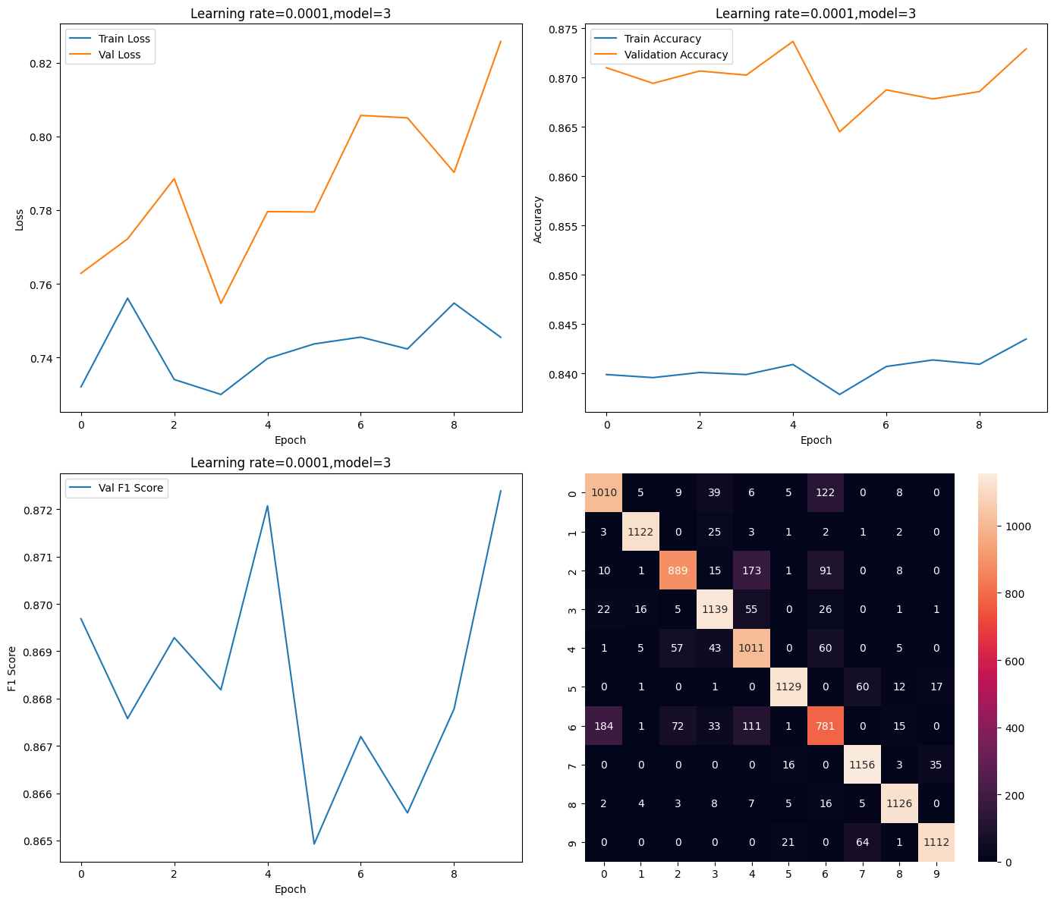

Train Loss: 0.745493365053453

Val Loss: 0.8257647428411562

Train Accuracy: 84.34791666666666 Val Accuracy: 87.29166666666667 F1 Score: 0.8723882355055623

# Best model:



Test Accuracy: 87.06%

Test F1-score: 0.9726720647773279